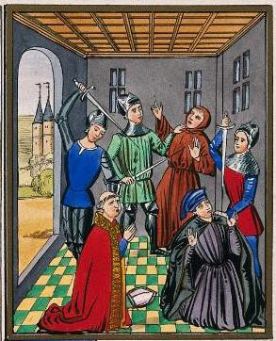

Original image
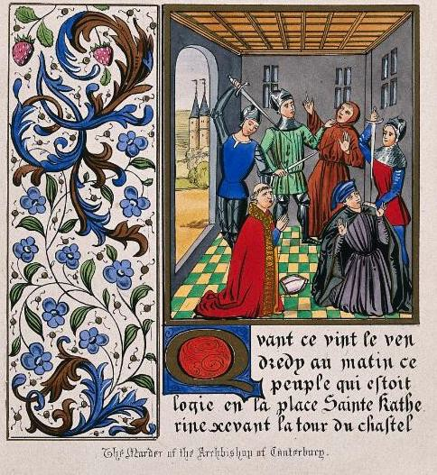
A

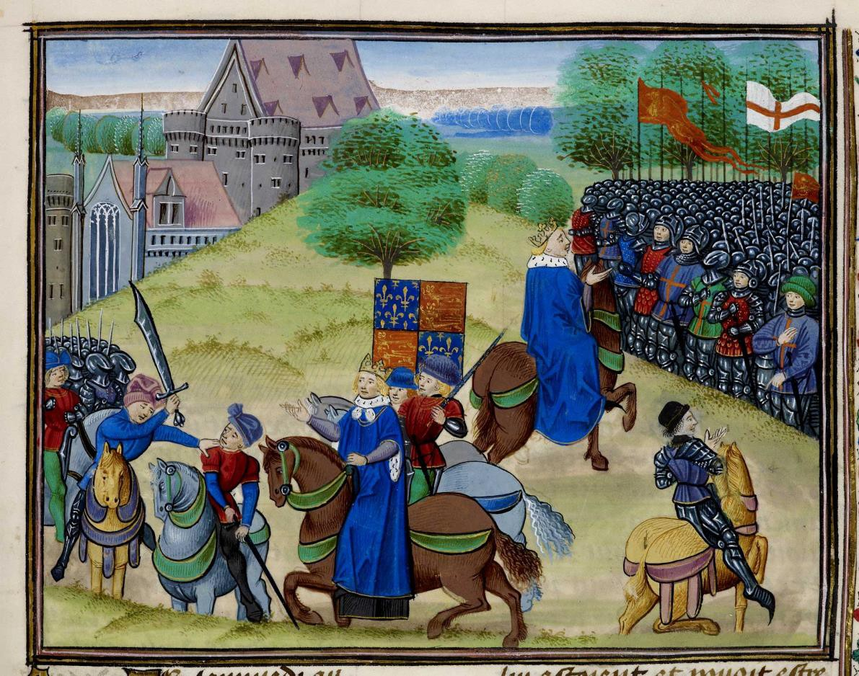
This illumination from Chronicles by Jean Froissart actually shows two scenes from the same event. The first scene is on the left, and the second is on the right.
Original image
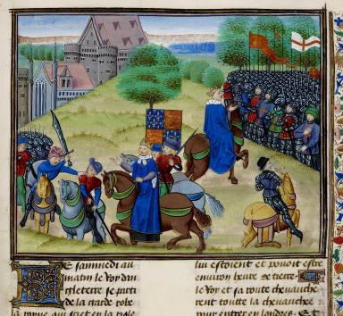
B

Here are some long-term causes that historians have suggested:

- The Black Death (1349) had killed so many people that there was a shortage of workers.
- Worried lords tried to use new laws (1351) to stop
workers leaving or demanding higher wages.
- Many peasants had to go to fight in the wars against France, leaving behind their homes and families.
- Some peasants wanted a chance to get rid of people whom they hated, like lawyers and some churchmen.

C

From a modern textbook
There had been several new taxes. The most hated was the Poll Tax.
This had to be paid by everyone (not just one household), which was different to previous taxes.

It also had to be paid by everyone over the age of 15.

It was set at one shilling – about two weeks work for a peasant. All people had to pay the same amount.

D

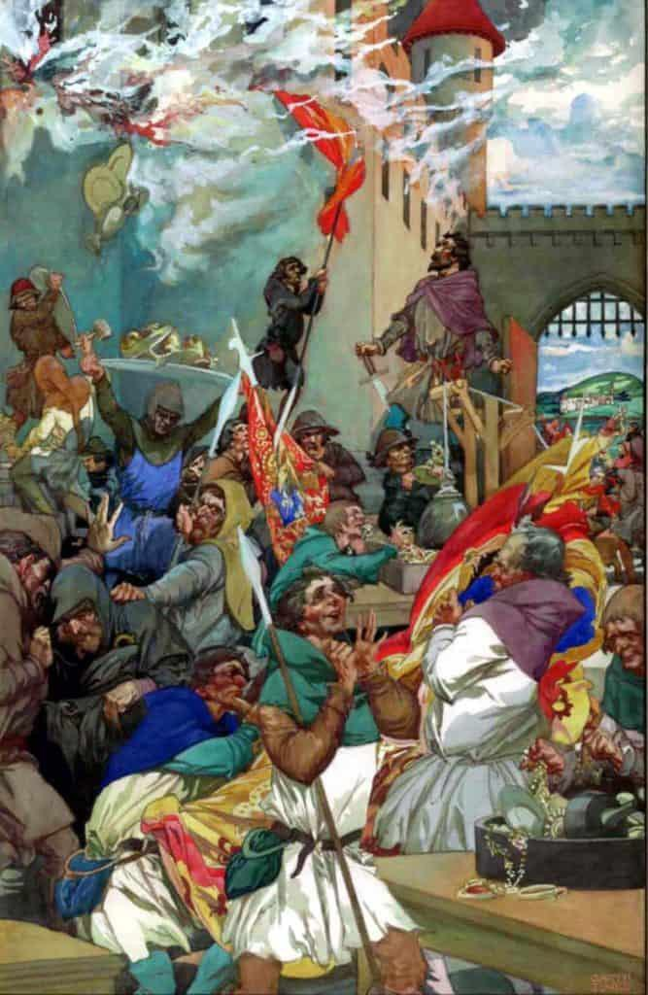
The burning of the Savoy Palace in London. It was owned by John of Gaunt, Duke of Lancaster.

Painted by Alfred Garth Jones, c. 1900

John of Gaunt, Duke of Lancaster, was uncle to the king, a powerful noble. He was incredibly rich and owned lots of land across England. Some thought he wanted to be king himself.
E

From History of England, a chronicle by Thomas
Walsingham.

The King’s words to the Essex peasants:

Oh you wretched men. You who want to be equal with your lords are not worthy to live. Villeins you were and villeins you shall remain.

F
Wretched – miserable, inferior
Villein – a peasant who isn’t he free – owes something (eg labour) to the local lord

From Chronicles by Jean Froissart:

These evil creatures in the counties became presumptuous. They said their servitude was too harsh and that there were no serfs when the world began. They had been much stirred up in these lunatic ideas by a mad priest called John Ball.

‘Good people,’ he would say, ‘nothing can go well in England, nor ever will do, until all goods are held in common, until there is neither villein nor nobleman.’

G
Servitude – owing something to someone else – a form of slavery Serfs – a peasant who wasn’t free, eg had to ask lord for permission to leave the village. A form of slavery

From the chronicle by Henry Knighton, written in 1381.

Judge Tresillian spared no one. Peasants accused of rebellion, whether justly or out of hatred, were beheaded, hung or drawn and quartered. John Ball was drawn and quartered. His intestines were cut out and burned while he was still alive. Then he was hung and his body cut into four. Pieces were sent to be put on show in different places in the kingdom.

H

From Anonimalle Chronicle:
At this time the commons of the southern England suddenly rose in two groups, one in Essex and the other in Kent. They directed their evil actions against the duke of Lancaster and the other lords of the realm because of the exceptionally severe tenths and fifteenths and other subsidies lightly conceded in parliaments and extortionately levied from the poor people. These subsides did nothing for the profit of the kingdom but were spent badly and deceitfully to the great impoverishment of the commons – and it was for this reason, as you will now hear, that the commons rose.

I
John of Gaunt, Duke of Lancaster, was uncle to the king, a powerful
noble. He was incredibly rich and owned lots of land across England. Some thought he wanted to be king himself.
Subsidies = taxes

From Anonimalle Chronicle:

Afterwards the King sent out his messengers to capture the wrongdoers and put them to death. Many were taken and hanged at London, and they set up many gallows around the City of London, and in other cities in the south. At last the King seeing that too many of his subjects would be undone and too much blood spilt, took pity. He granted them all pardon, on condition that they should never rise again, under pain of losing life or limb. Each man should get his charter of pardon, and pay the King a fee of twenty shilling, to make him rich.

J
Gallows – places where people were hung/executed

From Froissart’s Chronicles:
Wat Tyler spurred his horse and came close to the King. Then he said, ‘Do you think, King, that these people will go away from you without having your signed guarantees?’ ‘No,’ said the King, ‘you shall have them. They are ordered for you and shall be given to every one. So, good fellows, go back to your people and get them to leave London.’
Wat Tyler cast his eyes on a squire who was there carrying the King’s sword. Wat Tyler hated that squire because he had annoyed him before. ‘Give me that sword,’ said Tyler. ‘No,’ said the
squire. ‘It is the King’s sword. You are not fit to have it for you are only a knave.’ ‘By my faith,’ said Tyler, ‘I shall never eat meat until I have your head.’
At that moment the Mayor of London arrived with twelve knights, all well-armed, and broke through the crowd. He said to Tyler, ‘Ha! Would you dare to speak like that in front of the
King?’ The King began to get angry and told the Mayor, ‘Set hands on him.’ Tyler said to the Mayor, ‘What have I said to annoy you?’ ‘You lying, stinking, crook,’ said the Mayor, ‘would you speak like that in front of the King?’ By my life, you’ll pay dearly for it.’
And the Mayor drew out his sword and struck Tyler such a blow on the head that he fell down at the feet of his horse. The knights clustered round him so he could not be seen by the rebels. Then a squire called John Standish drew out his sword and put it into Tyler’s belly and so he died.
Seeing their leader killed, the people began to murmur and said ‘Let’s go and kill them all.’ And they got themselves ready for battle.
The King road alone to these people and said, ‘Sirs, what is the matter? You shall have no leader except me. I am your king. Be peaceful.’
Most of the people were ashamed and began to leave.
K
*The guarantees were written promises that the Kings would give the peasants their freedom and they would not punished.
Squire – a type of servant Knave – dishonest person

From Henry Knighton's chronicle:
The rebels returned to the New Temple which belonged to the prior of Clerkenwell... and tore up with their axes all the church books, charters and records discovered in the chests and burnt them…One of the criminals chose a fine piece of silver and hid it in his lap; when his fellows saw him carrying it, they threw him, together with his prize, into the fire, saying they were lovers of truth and justice, not robbers and thieves.

L
Clerkenwell and New Temple are both places in London.

Optional challenging sources

Pleas held before Hugh la Zouche and his associates, justices of the lord king appointed to subdue, punish and chastise rebels and disturbers of the peace in the aforesaid county [Cambridgeshire] on Tuesday immediately before the feast of St Margaret the Virgin, in the fifth year of the reign of King Richard the Second [16 July 1381]:

John Shirley of the county of Nottingham was arrested on the grounds that he was clearly wandering through divers counties at the time of the [recent] disturbance, rebellion and mayhem, spreading lies and falsehoods from region to region, likely to cause trouble and to breach the king’s peace and alarm and disturb the people, and for making derogatory statements after the proclamation of the king’s peace on the abovementioned day and year. While the justices of the lord king were present and resident in the town, he said in an inn in Bridge Street in Cambridge, where many people had gathered to hear fresh falsehoods from him, that the stewards of the lord king, his justices and many of his officials were more worthy to be drawn and hanged and suffer the other punishments and tortures prescribed by the law than the priest, John Ball, who had been convicted by law as a traitor and a felon, because he said that [Ball] had been condemned to death by the said ministers, with the assent of the king, falsely, unjustly and maliciously, simply for being a true and honest man, speaking out about the councils and courts of the realm and telling of the injustices and oppressions inflicted by the king and the said ministers upon the people, and his death will not go unpunished, but within a short time will be repaid by the king and his officials and ministers. These words and threats were both injurious to the crown and made to the manifest contempt and alarm of the people. Whereupon the said John Shirley was immediately taken by the sheriff before the said justices in Cambridge castle, where he was interrogated about these matters and closely examined concerning the conduct of his life and his place of residence and also with respect to his status. This information was acknowledged by him before the justices, and it was clearly established that he was of low bearing and estate. In addition trustworthy witnesses were questioned who had been present at the time that he had spoken these lies, evil words, threats and falsehoods, and after they had been sworn to tell the truth about these matters, they gave evidence that all the things that he was alleged to have said, had indeed been said by him, and when he was examined separately, he did not deny the allegations.
Therefore, by judgement of the said commissioners, he was hanged. And the escheator was ordered to inquire diligently into his lands and tenements, goods and chattels, and to dispose of them accordingly on behalf of the king.

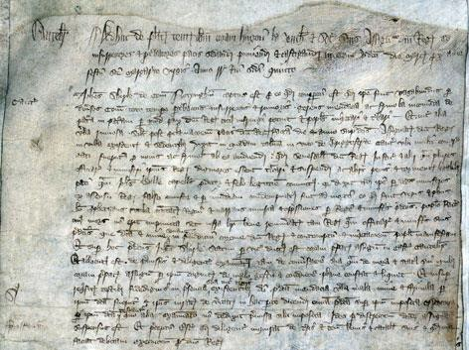
Original source

i

Petition of tenants of Cadney and Howsham in Lincolnshire conc. dispute with the Prior of Newstead

Likewise the said Prior, on the day before the Decollation of St John the Baptist in the fourth year of our lord the king that now is [28 August 1380] he came with force and arms with a great multitude of men arrayed for war and took the carts and ploughs from each of the tenants with all their equipment and carried them off to the castle of Somerton… of his said lordship and withheld them wrongfully until the Friday in the week of the following Christmas.

Likewise since by various acts the said Prior has come to many of the said tenants and taken their ploughs with equipment and withheld them for a long time, so that their lands are not prepared or tended, to the great ruin of the said tenants always. For which reason the said poor tenants beseech if you please and as a work of charity to have the said Prior appear before you to respond to the wrongs and crimes aforesaid, understanding that the common law cannot at all suffer to those for their poverty, and the great power and maintenance that the said Prior has in these matters.

Original source
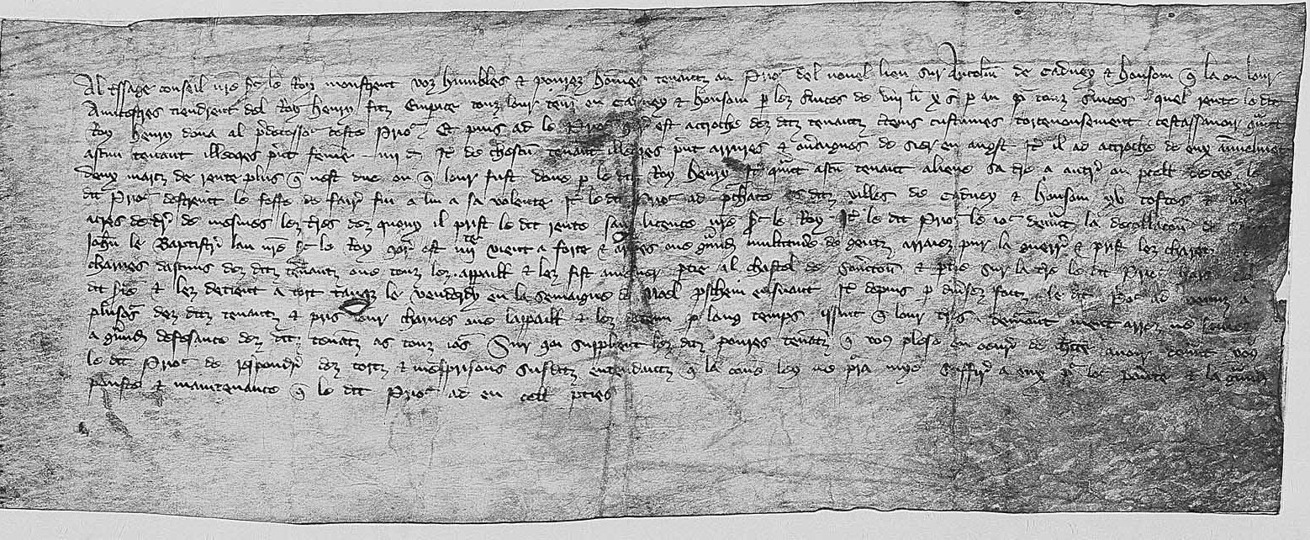
ii

Inquisition into offences committed in Essex, 1381

And furthermore they all rode armed through the peaceful countryside raising the aforesaid commons against the King and his laws to the Temple of the Priory of St John in England at Cressy and to the house of John Sewale of Coggeshalle, and they levelled the houses of the aforesaid Prior and John and feloniously came upon and took away their goods and chattels. Moreover, they say that on Friday next after the Feast of the Holy Trinity in the fourth year of the reign of the aforesaid King Richard II, John Wiltshire of Lesser Burstede freely and without compulsion lopped off the head of a certain esquire of the Duke of Lancaster called Grenefeld in the City of London.

Original source
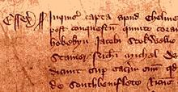
iii

